**Vatsal Makani**

**Wheelchair Status Report**

Successfully got the wheelchair working using W,A,S,D on LINUX PC.

1. We made use of a LINUX PC to connect the Discovery board on the PC via USB (UART1). Following steps were followed to accomplish it:
2. Open the terminal and type the command:

**$ dmeg |grep tty**

to find all the serial devices.

1. Plug the device and run the above command and again unplug the device and run the command.
2. Again, plug the device and see the difference in the message after the command.

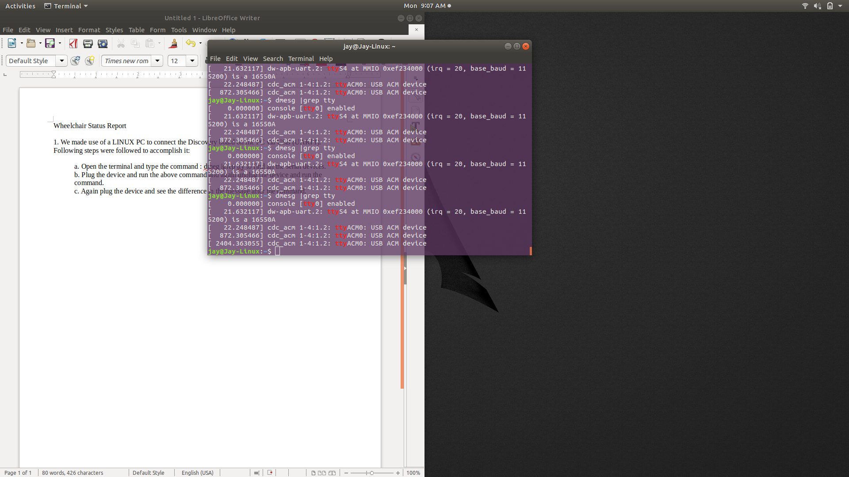

USB

unplugged

USB

plugged

1. Install putty using the command

**$ sudo apt-get install putty**

1. Open putty as superuser

**$** **sudo putty**

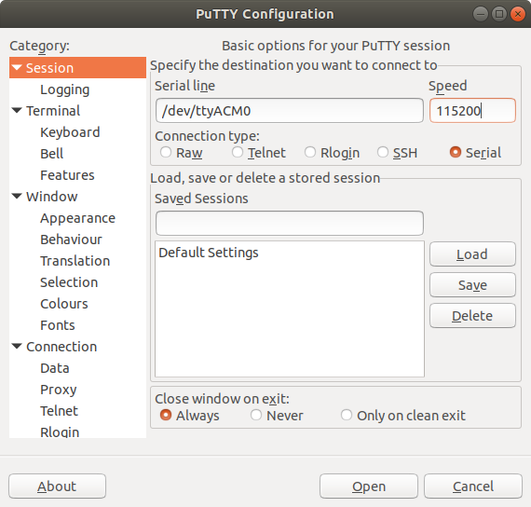

1. Select Serial session. Serial to ttyACM0 and baud rate as per the devices baud rate. And press connect.
2. If the device is not getting connected reset the device and try again.

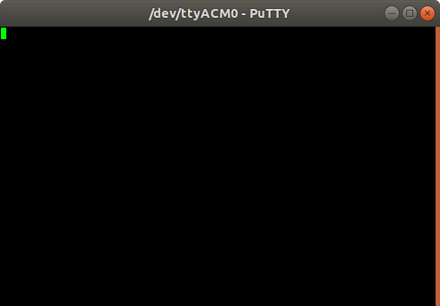

1. Press W, A, S and D to control the wheelchair using the keyboard and we will get the PWM values.

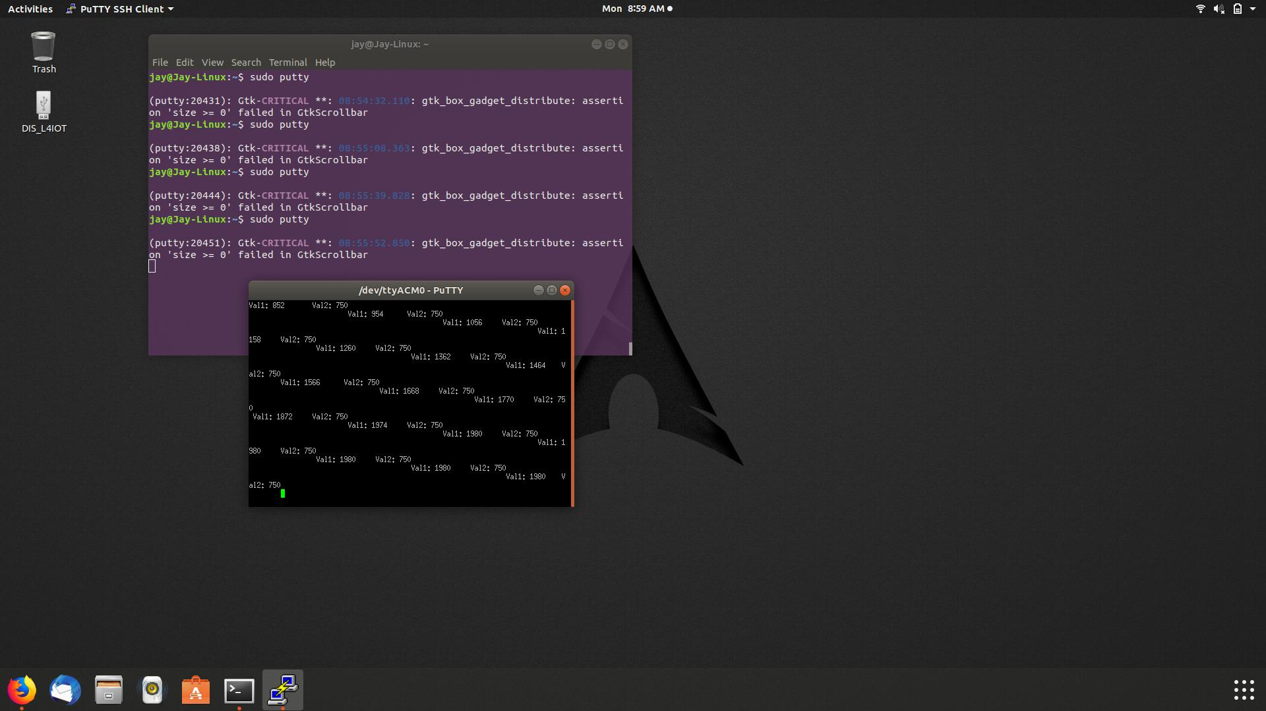

1. Tried to mirror the same steps on JETSON but was not able to connect to the serial port.
2. Tried many commands to find and list the USB devices and their ports but was not able to connect to the Discovery kit over USB (UART1).
3. I suspect this problem is occurring due to many devices connected to the same port via USB HUB.
4. Tried minicom and Putty to connect but did was unsuccessful.